Data Representation

Lab 4: JSON and AJAX (with jQuery)

Lecturer: Andrew Beatty

JSON

Etain’s answers;

1. Done;

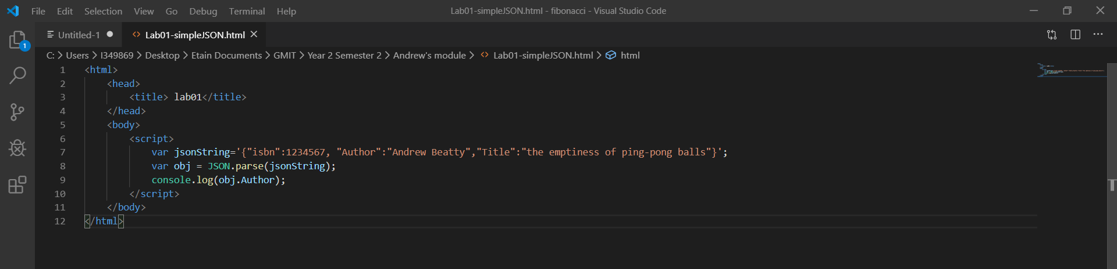

1. Done;

<html>

    <head>

        <title> lab01</title>

    </head>

    <body>

        <script>

            var jsonString='{"isbn":1234567, "Author":"Andrew Beatty","Title":"the emptiness of ping-pong balls"}';

            var obj = JSON.parse(jsonString);

            console.log(obj.Author);

        </script>

    </body>

</html>

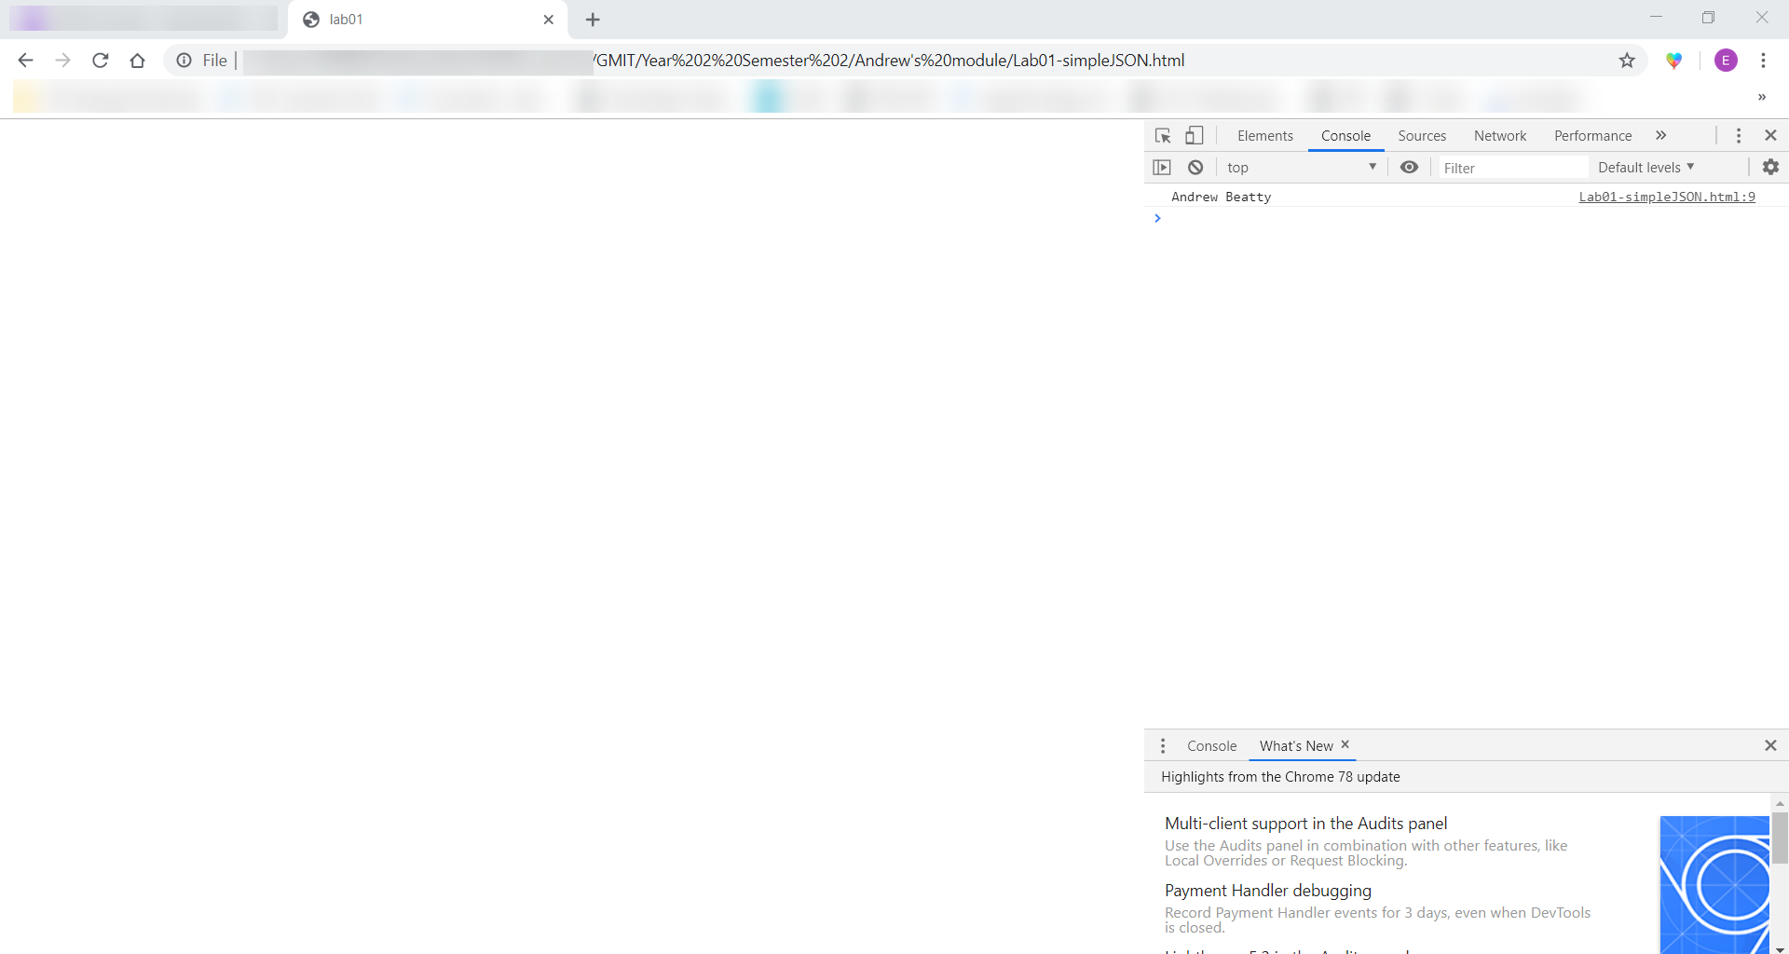

1. Done;

<html>

    <head>

        <title>lab02</title>

    </head>

    <body>

        <script>

            var jsonString ='{"employees":[{"firstName":"John", "lastName":"Doe"},{"firstName":"Anna", "lastName":"Smith"},{"firstName":"Peter", "lastName":"Jones"}]}'

            var obj = JSON.parse(jsonString);

            var employees = obj.employees;

            for(employee of employees){

                console.log(employee.firstName);

            }

        </script>

    </body>

</html>

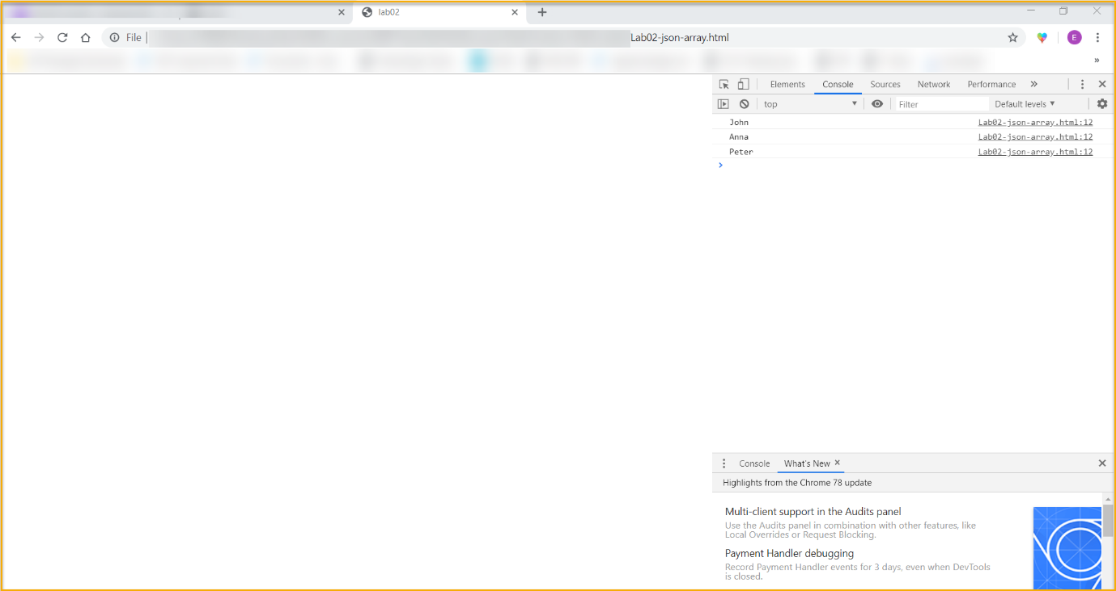

AJAX

1. Done;

<html>

    <head>

        <script src="https://ajax.googleapis.com/ajax/libs/jquery/3.4.1/jquery.min.js"></script>

        <title>lab03</title>

    </head>

    <body>

        <button onclick="readJSON()">go</button>

        <script>

            function readJSON(){

                $.ajax({

                    "url":"https://api.coindesk.com/v1/bpi/currentprice.json",

                    "method":"GET",

                    "data":"",

                    "dataType":"JSON",

                    "success":function(result){

                        console.log(JSON.stringify(result));

                    },

                    "error":function(xhr,status,error){

                        console.log("status:"+status+"message:"+error);

                    }

                });

            }

        </script>

    </body>

</html>

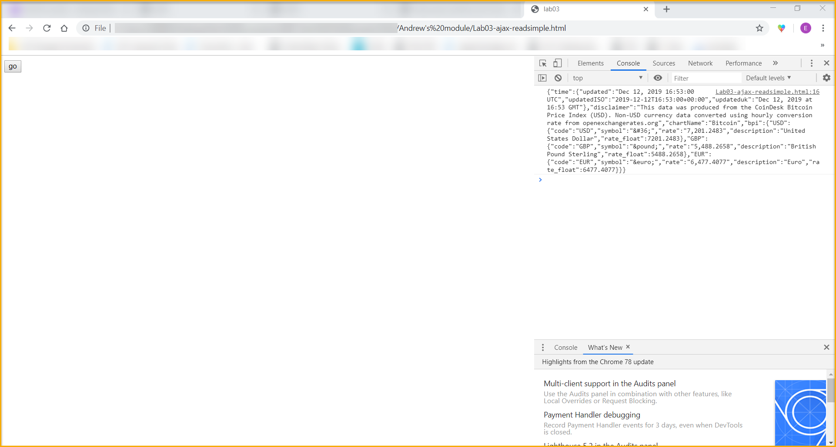

1. Done;

<html>

    <head>

        <script src="https://ajax.googleapis.com/ajax/libs/jquery/3.4.1/jquery.min.js"></script>

        <title>lab03</title>

    </head>

    <body>

        <button onclick="readJSON()">go</button>

        <script>

            function readJSON(){

                $.ajax({

                    "url":"https://api.coindesk.com/v1/bpi/currentprice.json",

                    "method":"GET",

                    "data":"",

                    "dataType":"JSON",

                    "success":function(result){

                        var rate = result.bpi.EUR.rate;

                        console.log(rate);

                    },

                    "error":function(xhr,status,error){

                        console.log("status:"+status+"message:"+error);

                    }

                });

            }

        </script>

    </body>

</html>

